Comrade Gonzalo has become immortal!

Dr Abimael Guzman (Comrade Gonzalo), chairman of the Communist Party of Peru aged 86, was martyred early morning on 11th September 2021 in the high security prison in the Calao naval base by the fascist regime in power in Peru. Comrade Gonzalo remained in isolation since his arrest on 12th September 1992. Following his famous speech on 24 September 1992 he was condemned to life imprisonment and since then for 29 years has remained in a grave like prison without any contact with the outside world.
The 29 years of isolation and torture and final execution of the comrade in the hands of the fascist regime in Peru is a solid reminder of the class hatred of the bourgeoisie against the people and their representatives, the proletarian fighters. They suspend and reject all international conventions and protocols of human right political prisoners and prisoners of war. Comrade Gonzalo, despite his age never gave up and resisted the persistent torture and inhumane treatment by the ruling classes in Peru.
Dr Abimael Guzman spent all his adult life in the service of the proletariat resisting imperialism and reaction. He led the struggle against Khrushchevite modern revisionism in Peru in mid 1960s aiming to re-establishing the Communist Party of Peru in continuation of the teachings of comrade José Carlos Mariátegui and the founder of the Communist Party of Peru, that was established in the 1928. He led the re-establishment of the Communist Party of Peru and advocated the view that "the fight against revisionism and opportunism is inseparable from the fight against Imperialism and reaction".
As representative of the party he travelled several times to China taking notes and learning from the experiences of the Communist Party of China (CPC)under the leadership of comrade Mao Tse-tung. He travelled to China in early 1967, the during the January Storm in Shanghai and was immensely inspired by the Great Proletarian Cultural Revolution (GPCR) and Mao Tse-tung’s teaching. He defended Marxism-Leninism Mao Tse-tung Thought, on his return to Peru and was determined to fully realise the rupture from revisionism and the “Peruvian Communist Party” that had sunk deeper in modern revisionism betraying the proletariat and the principals of Marxism-Leninism and was colluding with imperialism and reactionaries.
The ultimate revolutionary rupture and challenge came with the launch of armed struggle on 17 May 1980, that was aimed at advancing and launching of a full-scale peoples’ war against the Peruvian puppet state as a strategy to advance the New Democratic Revolution in Peru.
Comrade Gonzalo was one of the first Marxist-Leninists-Maoist to raise the evaluation of comrades Mao’s contribution to the proletarian science as a new higher stage of Marxism and upheld and defended Marxism-Leninism-Maoism.
By 1990 the peoples’ war had advanced so widely that the capital Lima was under threat of capture by the revolutionary forces led by the party. The imperialist powers and reactionaries watched in horror as the proletariat and the oppressed peoples of the world heard the revolutionary voice of liberation from Ayacucho.
Comrade Gonzalo and his comrades was captured on 12 September 1992 in Lima. On September 24, undeterred and with revolutionary zeal comrade Gonzalo delivered a fiery speech transmitted across the world through mainstream media. In his inspirational speech he declared his arrest was “just a bend in the road” for the revolution and called on his comrades and the international proletarian forces to continue and to advance the struggle against imperialism and all reaction.
Today as we mourn the death of comrade Gonzalo and extend our heartfelt sorrow to the Communist Party of Peru (CPP) and the workers and the toiling masses of Peru, we declare that comrade Gonzalo will continue to live in our struggles.
The Memory of President Gonzalo Lights Our Way!
Comrade President Gonzalo is Immortal!
Communist Party of Turkey – Marxist Leninist (TKP-ML)
Central Committee
September 13, 2021
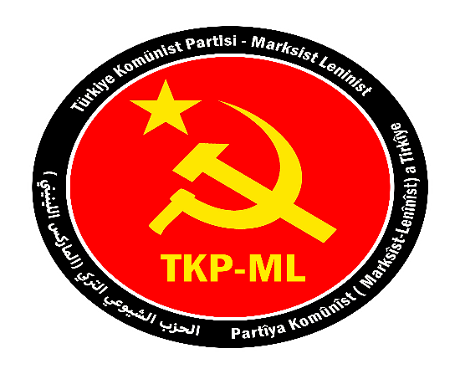

Link: https://www.tkpml.com/tkp-ml-central-committee-comrade-gonzalo-has-become-immortal/

