Statement No: 2021/1

EVERYWHERE IS BOGAZICI, EVERYWHERE IS RESISTANCE!

In recent weeks, we have been experiencing a series of developments from the resistance of the working class all over the country, the efforts to knit the united struggle against fascism, the reflection of the unquenchable rebellion of women on the streets, and the rising youth movement, especially with the appointment of trustees at Bogazici University. Of course, these developments did not come out of nowhere. Especially since the 2015 General Elections and then the 2016 “coup” attempt, this is another aspect of the process that started as the ruling classes showed the face of the state to all segments of the population more and more brutally. On this side of the process, there is anger accumulating at the bottom. Workers, laborers, women, young people, LGBTI +, Kurdish, Armenian, Alevi ... all people say “Enough is enough, Edi Bese” on this side of the process!

The real Terrorist is the blood sucking AKP-MHP!
With the appointment of a trustee rector to Bogazici University, the resistance initiated by the university components has now evolved into a new phase. The trustee policy of the fascist government formed by the AKP-MHP and Ergenekon residues is not new. The state, which appoints trustees to the municipalities elected by the people in Kurdish provinces, has turned to universities to achieve its "ideological hegemony", as it did in the fascist R. T. Erdogan's admission that "We could not establish our intellectual power".
As if fascism's intervention in universities under the grip of YÖK (The Council of Higher-Education) is not enough, this time it prefers to directly appoint its own "militant" rectors. However, this time, when it finds resistance, it both resorts to black propaganda through his ideological devices and activates naked fascist terror. Although dozens of students were detained under fascist terror at the beginning of the resistance, the actions that could not be finished evolved into a different stage.
The desperation of fascism in the face of the resistance brought with it the activation of various provocations, the aim of breaking the united and common character of the resistance that existed from the very beginning, accompanied by black propaganda. LGBTI + 's were declared heretics through the mouth of a fascist person named S.S, the Minister of Interior, and students were targeted under the name of "insulting national and religious values". The bourgeois parties opposing this black propaganda of the AKP-MHP fascist government also supported this target, and because of this targeting, again students were detained and arrested.
It is known that; Whenever the ruling classes talk about "national and moral values" there is a fascist hypocrisy, fraud, and distortion. There is a resorting to ideological manipulation, lies and black propaganda against the extremely just and legitimate resistance. Those who left the people with “virus or unemployment, hunger and poverty?" dilemma, these terrorists, those who put all kinds of theft, corruption, client-favouritism and fascist prohibitions into effect once again took refuge in the lie of "national and moral values" in the face of the justness and legitimacy of the resistance.
Fascism, by putting forward "national and moral values" to cover up the decay and corruption it suffers, is the main reason behind the exploitation and unemployment imposed on the working class, the foreclosures imposed on the peasants, the attacks imposed on the Kurdish people, the denial and threats imposed on the Alevis, the massacres of women, harassment and rape, and the animals. It wants to cover the persecution and massacres, the pillage of the environment and nature with the veil of "national and moral values". The ruling classes link all evil to the absence of "national and moral values" through ideological propaganda devices. But in fact, the veil over all evil is just “national and spiritual values”! What they call "national and spiritual values" is the curtain of exploitation, darkness, and injustice!
The regime's propaganda of "insulting national and moral values" continued by showing the just and legitimate resistance of the student youth in connection with "terror". The Minister of Interior S.S tried to associate the extremely just and legitimate resistance of the student youth with the organizations, including our party, and thus aimed to legitimize fascist aggression and terror.
Our party is a direct or indirect part of every just and legitimate action and every resistance against fascism. It aims for every action and resistance to grow even more and serve the overthrow of fascism. Communists never hide their views. Our goal is to destroy Turkish fascism and to establish the Democratic People's Power. Trying to “terrorize” the resistance of our party and revolutionary organizations by criminalizing the resistance of the university components, especially the students of Bogazici University, is nothing more than the hypocritical and vile propaganda of fascism.
As a matter of fact, despite this black propaganda, the resistance initiated by the university components, especially Bogazici University students, caused the Hisarustu Campus to spread from the North and South gates to the whole country. Now, “Everywhere is the Bogazici, everywhere is resistance. In other provinces of the country, university components, especially the student youth, took to the streets and embraced the resistance. Fascism also attacked these actions with utter audacity.
No matter how much the rulers try to criminalize this extremely just and legitimate resistance of the youth, they have already lost. No matter how much the ruling classes want to hide the crisis of failure to manage, first with their explanations of "reform" in the judiciary and economy, and now with the work of a "new" constitution, they will not escape the truth. Unified Revolutionary action of the youth would void all the policies of fascism.
The small but widespread resistance and actions of the working class, the struggle to protect the nature and living spaces of the peasantry, the endless rebellion and anger of women and LGBTI +, the extremely just, legitimate, democratic demands of the Kurdish nation and various nationalities and beliefs, especially the Alevi faith, it is certain that we will win the struggle for it to the extent that it merges with the United Revolutionary Struggle of the youth.
In this sense, the move to Demolish Fascism and Gain the Freedom will combine with the street-by-street rage of the youth in our country, especially the components of Bogazici University. Now is the time to embark on new "Gezi" s, to say "Everywhere is Bogazici, everywhere is Resistance".

Long Live the Unbending Struggle of the Youth!
We Shall Demolish Fascism and Gain Freedom!

TKP-ML Polit Bureau
February 2021
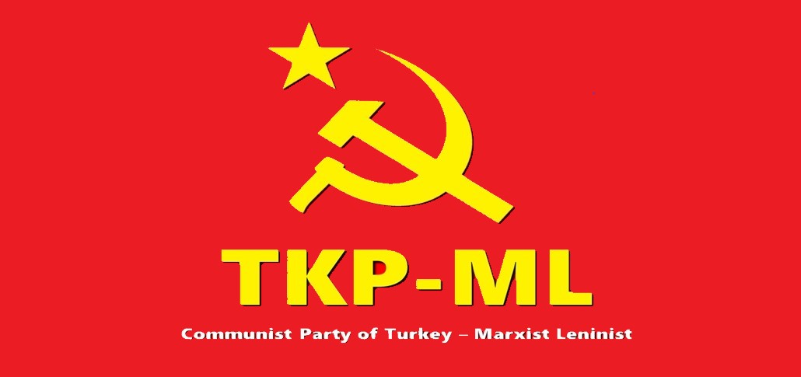
Englısh: https://www.tkpml.com/tkp-ml-polit-bureau-everywhere-is-bogazici-everywhere-is-resistance/

