Maoist Splinters in Bid to Merge with Mother Party

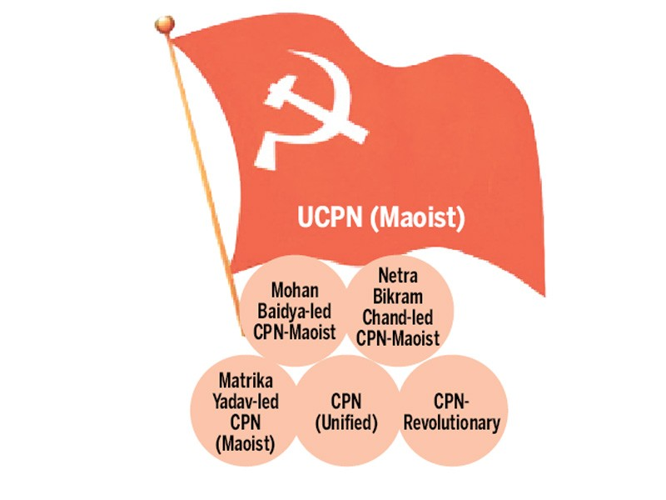
Kathmandu Post/ekantipur.com
Jan 17, 2016- Different Maoist parties, which came into being after they parted ways with the UCPN (Maoist), are working to merge with the mother party to make a united force and have started what they call a unification campaign.
The Maoist party, which launched a decade-long “People’s War”, joined peaceful politics in 2006, but in the subsequent years, it went suffered multiple splits, as leaders kept on leaving the mother party, accusing it of “deviating from the ideology”.
There are now five Maoist splinter groups-Mohan Baidya-led CPN-Maoist, Netra Bikram Chand-led CPN-Maoist, Matrika Yadav-led CPN (Maoist), CPN (Unified) and CPN-Revolutionary.
The campaign aims to bring all the Maoist parties together on February 13, which is observed by them as “People’s War Day”.
Baburam Bhattarai, who severed ties with the UCPN (M) in September last year following the promulgation of the constitution, however, is in a bid to form a new party which he calls “Naya Shakti” and does not seem keen about returning home. The UCPN (M) and its breakaway factions have been under pressure from within the parties for unification. Several rounds of talks have also been held, but with little progress.
A group of people such as Shanta Shrestha, Gopal Siwakoti, Dipendra Rokaya, Borna Bahadur Karki, Ram Chandra Humagain and Nilam Prabha among others, who said to be close to these Maoist parties, have been pressing leaders of these parties to go for unification. They are even pressing them to announce the unification on Republic Day, which is observed on May 29.
Before the promulgation of the constitution, these Maoist parties were “in a working alliance” against local elections. But after the UCPN (M) decided to participate in the constitution drafting process, the alliance became dysfunctional.
Of late, the Baidya-led CPN-Maoist, the first one to part ways with the Pushpa Kamal Dahal-led establishment Maoist party in 2012, has shown some positive signs about merger.
Its senior leader Dev Gurung has publicly said that despite some differences, unification is the need of the hour, as only a strong Maoist party can “work jointly for the welfare of the country”.
“Discussions are underway at various levels for unification,” said Gurung.
The CPN-Maoist has formed a committee of office bearers to hold talks with other parties for unification. The committee comprises party Chairman Mohan Baidya, Vice-Chairman CP Gajurel, General Secretary Ram Bahadur Thapa and Secretary Dev Gurung.
According to leaders, other breakaway Maoist parties are ready for unification. The main challenge is unification between Dahal-led UCPN (M) and Baidya-led CPN-M.
Baidya’s colleagues Dev Gurung, Ram Bahadur Thapa and CP Gajurel are of the view that unification is a must despite differences, but Baidya has reportedly been saying that he would rather lead a party made up of fringe Maoist forces than give up his ideology for “the sake of unification”. When Baidya and his aides, including Netra Bikram Chand, had decided to split from the UCPN (M), they had said that Dahal had “deviated from the ideology”. Interestingly, when Chand decided to part ways with Baidya to form his own Maoist party two years later in 2014, the charge he made against Baidya was similar to what Baidya had made against Dahal.
While the fringe Maoist parties are pushing for unification with the mother party, UCPN (M) Chairman Dahal is learnt to have been paying court to the ruling CPN-UML to form an alliance for local and other elections.
According to leaders, Dahal has proposed “an election alliance” with the UML, but latter is yet to respond. Dahal is currently on a nation-wide campaign to “revamp the party organisations”.
Published: 17-01-2016 08:22

http://kathmandupost.ekantipur.com/news/2016-01-17/maoist-splinters-in-bid-to-merge-with-mother-party.html

